
Weekly Homework: Must do’s!
- Read each night and record in your reading diary (checked every Friday)
- Practice spellings weekly from the list in your homework book. Evidence this in your homework book. Children should practise words from the spelling list stuck into the front of their homework book. Choose 3-5 words each week to practise and an activity from the spelling menu. This should be recorded in their homework book. This spelling list will be assessed each half term. Words your child can already spell will be highlighted so you know which to focus on.
- Practise number facts using games from the app ‘1 minute maths’ by White Rose daily

Homework Menu: Each week, choose one task to complete.
By the end of the half term, try to have a mix of creative, written, and practical pieces. Present your work neatly and be as imaginative as possible! We will share and celebrate homework in class on a Friday.
Dynasty Timeline  Create a simple timeline showing key Chinese dynasties and one fact about each | Traditional Clothing Design  Design a traditional Chinese outfit. Label the colours, patterns, and materials used | Yangtze River Study  Create a fact page about the Yangtze River. Include its length, importance, and wildlife. | Chinese Animal  Research an animal that lives in China (e.g. panda, snow leopard, crane). Present facts and a labelled picture.
Mandarin Words List  Learn 5 simple Mandarin words or phrases. Write them, say what they mean, and decorate your page. | Shadow Puppet Show  Make a simple shadow puppet and write a short script inspired by a Chinese folktale. | Kung Fu Movement Log  Research a martial art from China. Describe or safely practise a few movements and explain their purpose. | Mountain Landscapes Art  Create a landscape inspired by traditional Chinese ink paintings (mountains, mist, rivers).
Major Cities Research  Choose one major Chinese city (e.g. Beijing, Shanghai, Hong Kong) and create a mini travel page about it. | Famous Landmarks Sketchbook  Draw and label 3 famous landmarks in China (e.g. Forbidden City, Temple of Heaven) | Porcelain Plate Design  Design a blue-and-white plate inspired by traditional Chinese porcelain. | Fan Decoration  Make and decorate a folding fan with patterns or symbols.
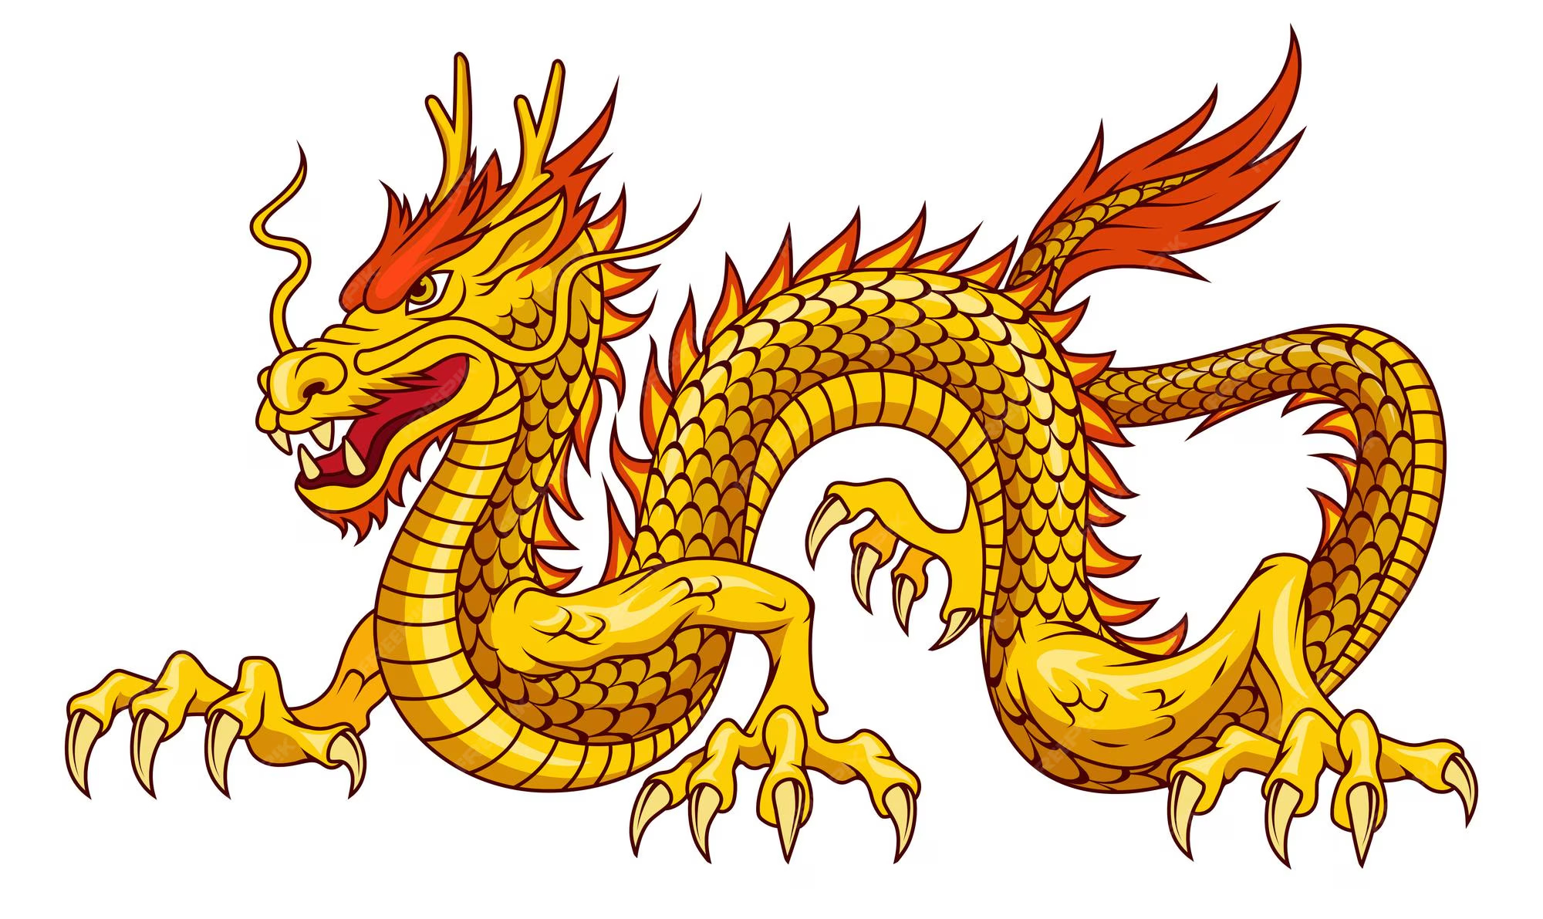
All homework is handed out on a Friday and is due the following Friday
Homework – Year 5
Term 2:2 Topic: China

